**Sri Srinivasan**

**Relational Databases with MySQL**

**Week 2 Coding Assignment**

**Points possible:** 70

|  |  |  |
| --- | --- | --- |
| Category | Criteria | % of Grade |
| Functionality | Does the code work? | 25 |
| Organization | Is the code clean and organized? Proper use of white space, syntax, and consistency are utilized. Names and comments are concise and clear. | 25 |
| Creativity | Student solved the problems presented in the assignment using creativity and out of the box thinking. | 25 |
| Completeness | All requirements of the assignment are complete. | 25 |

**Instructions:** Using a text editor of your choice, write the queries that accomplishes the objectives listed below. Take screenshots of the queries and results and paste them in this document where instructed below. Create a new repository on GitHub for this week’s assignments and push this document, with your Java project code, to the repository. Add the URL for this week’s repository to this document where instructed and submit this document to your instructor when complete.

**Coding Steps:**

Write queries to address the following business needs.

1. I want to know how many employees with each title were born after 1965-01-01.

**Please note:** I have based my query on currently employed people. For this I had to use the employees, titles, and the current_dept_emp tables.

SELECT t.title as "Title", COUNT(e.birth_date) AS "# Born after 1965-01-01" from titles t

INNER JOIN employees e ON e.emp_no = t.emp_no

INNER JOIN current_dept_emp cde ON cde.emp_no = e.emp_no

WHERE e.birth_date > '1965-01-01' AND cde.to_date = '9999-01-01'

GROUP BY t.title;

1. I want to know the average salary per title.

SELECT t.title as "Title", AVG(s.salary) AS "Average Salary" from titles t

INNER JOIN salaries s ON s.emp_no = t.emp_no

INNER JOIN current_dept_emp cde ON cde.emp_no = s.emp_no

GROUP BY t.title;

3. How much money was spent on salary for the marketing department between the years 1990 and 1992?

SELECT d.dept_name as "Department", SUM(s.salary) AS "Total Salary from 1990 to 1992" from departments d

INNER JOIN dept_emp de ON de.dept_no = d.dept_no

INNER JOIN salaries s ON s.emp_no = de.emp_no

WHERE d.dept_name = 'Marketing'

AND de.from_date > '1989-12-31' AND de.to_date < '1993-01-01';

**SCREEN**

**SHOTS**

**BELOW:**

**Screenshots of Queries:**

1. *I want to know how many employees with each title were born after 1965-01-01.*

***Please note:*** *I have based my query on currently employed people. For this, I had to use the employees, titles, and the current_dept_emp tables.*

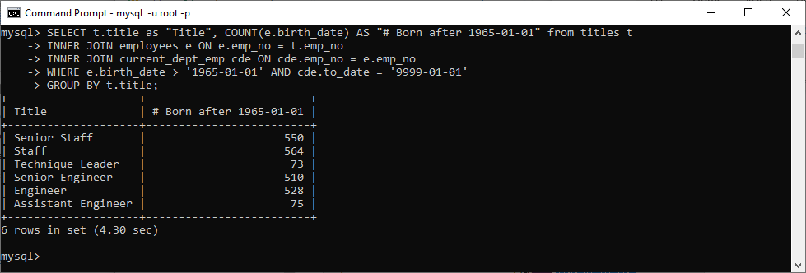

1. *I want to know the average salary per title.*

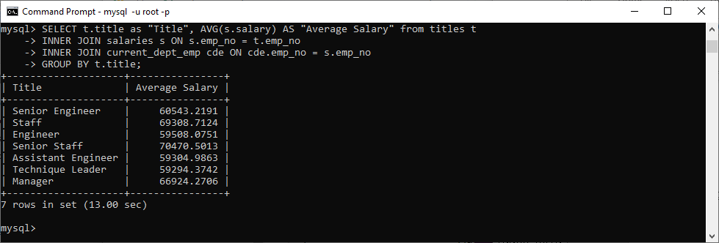

*3. How much money was spent on salary for the marketing department between the years 1990 and 1992?*

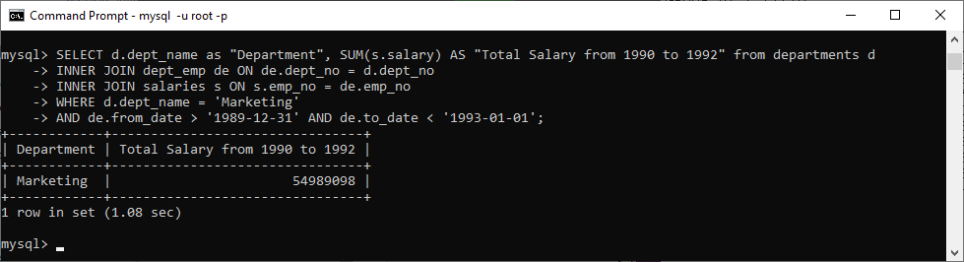

**Screenshots of Query Results (only include the last 20 rows):**

1. *Write queries to address the following business needs.*



1. *I want to know the average salary per title.*



*3. How much money was spent on salary for the marketing department between the years 1990 and 1992?*



**URL to GitHub Repository:**

[**https://github.com/srikripa/MSQL-Repos-2.git**](https://github.com/srikripa/MSQL-Repos-2.git)